Vanessa Lobo
180905316
CSE-A
Roll no: 37

LAB 2

Q1:
#include <mpi.h>
#include <string.h>
#include <stdio.h>
#define MAX 100
int main(int argc, char *argv[])
{
int rank, size, len;
MPI_Init(&argc, &argv);
MPI_Comm_rank(MPI_COMM_WORLD, &rank);
MPI_Comm_size(MPI_COMM_WORLD, &size);
MPI_Status status;
char word[100];
if(rank==0){
printf("Enter a word in Process 0\n");
scanf("%s", word);
len=strlen(word);
//printf("length=%d\n", len);
MPI_Ssend(&len, 1, MPI_INT, 1, 1, MPI_COMM_WORLD);
MPI_Ssend(&word, len+1, MPI_CHAR, 1, 2, MPI_COMM_WORLD);
printf("Rank: %d, Sent %s\n", rank, word);
MPI_Recv(&word, len+1, MPI_CHAR, 1, 3, MPI_COMM_WORLD, &status);
printf("Rank: %d, Received %s\n", rank, word);
fflush(stdout);
}
else{
MPI_Recv(&len, 1, MPI_INT, 0, 1, MPI_COMM_WORLD, &status);
MPI_Recv(&word, len+1, MPI_CHAR, 0, 2, MPI_COMM_WORLD, &status);
char temp[100];
printf("Rank: %d, Received %s\n", rank, word);

for(int i=0; i<strlen(word); i++){
if(word[i]>='A' && word[i]<='Z'){
temp[i]=word[i]+32;
}
else{
temp[i]=word[i]-32;
}
}

MPI_Ssend(&temp, len+1, MPI_CHAR, 0, 3, MPI_COMM_WORLD);
fflush(stdout);
}
MPI_Finalize();
return 0;
}

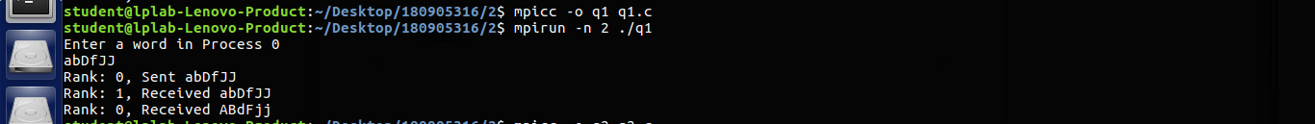

Q2:
#include <mpi.h>
#include <stdio.h>
#include <string.h>
int main(int argc, char *argv[])
{
int rank, size, num;
MPI_Init(&argc, &argv);
MPI_Comm_rank(MPI_COMM_WORLD, &rank);
MPI_Comm_size(MPI_COMM_WORLD, &size);
MPI_Status status;
if(rank==0){
printf("Enter a number to send:\n");
scanf("%d", &num);
for(int i=1; i<size; i++){
printf("Rank: %d, Sent: %d\n", rank, num);
MPI_Send(&num, 1, MPI_INT, i, 1, MPI_COMM_WORLD);
}

}
else{
MPI_Recv(&num, 1, MPI_INT, 0, 1, MPI_COMM_WORLD, &status);
printf("Rank: %d, Received: %d\n", rank, num);
}
MPI_Finalize();
return 0;
}
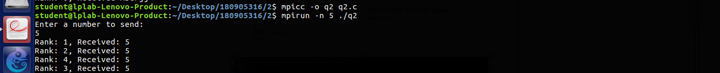

Q3:
#include <mpi.h>
#include <stdio.h>
#include <string.h>
#include<stdlib.h>
int main(int argc, char *argv[])
{
int rank, n;
MPI_Init(&argc, &argv);
MPI_Comm_rank(MPI_COMM_WORLD, &rank);
MPI_Comm_size(MPI_COMM_WORLD, &n);
MPI_Status status;
int bufsize=100;
int *arr=(int*)malloc(n*sizeof(int));
int buffer[bufsize];
int size=200;
//int size=n*sizeof(int);
MPI_Buffer_attach(buffer, bufsize);
if(rank==0){
printf("Enter array elements: \n");
for(int i=0; i<n; i++){
scanf("%d", &arr[i]);
}

for(int i=1; i<n; i++){
//printf("\n%d", arr[i]);
MPI_Bsend(&arr[i], 1, MPI_INT, i, 1, MPI_COMM_WORLD);
}

}
else{
int num;
MPI_Recv(&num, 1, MPI_INT, 0, 1, MPI_COMM_WORLD, &status);
//printf("num=%d\n", num);
if(rank%2==0){
int sq=num*num;
printf("Rank: %d, Squared number: %d\n", rank, sq);
}
else{
int cu=num*num*num;
printf("Rank: %d, Cubed number: %d\n", rank, cu);
}
}
//int size=n*sizeof(int);
MPI_Buffer_detach(&buffer, &bufsize);
MPI_Finalize();
return 0;
}

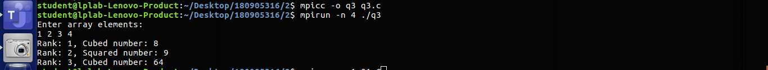

Q4:

#include <stdlib.h>
#include <stdio.h>
#include <mpi.h>
int main(int argc, char *argv[])
{
int rank, size, x;
MPI_Init(&argc, &argv);
MPI_Comm_rank(MPI_COMM_WORLD, &rank);
MPI_Comm_size(MPI_COMM_WORLD, &size);
MPI_Status status;
if(rank == 0){
printf("Enter a number: ");
scanf("%d", &x);
MPI_Send(&x, 1, MPI_INT, 1, 1, MPI_COMM_WORLD);
printf("%d sent %d to 1\n",rank, x);
MPI_Recv(&x, 1, MPI_INT, size - 1, 1, MPI_COMM_WORLD, &status);
printf("%d recieved %d from %d\n", rank, x, size-1);
}
else
{
MPI_Recv(&x, 1, MPI_INT, rank - 1, 1, MPI_COMM_WORLD, &status);
x++;
printf("%d recieved %d from %d\n", rank, x - 1,rank-1);
MPI_Send(&x, 1, MPI_INT, (rank + 1) % size, 1, MPI_COMM_WORLD);
}
MPI_Finalize();
return 0;
}

